**Mobile Development: Design Documentation**

**Requirements:**

**Core Features:**

1. Embedded videos of the walkthrough (allow for less navigation in finding what they want)
2. Clean & Simple UI (for younger audiences)
3. The 100% walkthrough guide

**Secondary Features**:

1. Animation(Animated GIF )
2. Simple tiles to indicate which level to navigate to

**Purpose and Overview of App:**

The purpose of this android app is to provide a 100% guide/walkthrough of the game Spyro remastered, Spyro 2 Gateway to Glimmer. This will be an in-depth guide to all levels in the game and how to obtain every collectable in order for the 100%. This guide will be in the form of both written and video. This app will also contain extra information on the game for example character information aswell as secrets and glitches in the game.

**Target Audience:**

The target audience of this app is primarily young first-time players of this game around 6-15 years old. Another audience that this app will target is older players ages 23+ that have nostalgia for the original Spyro 2.

**Existing apps:**

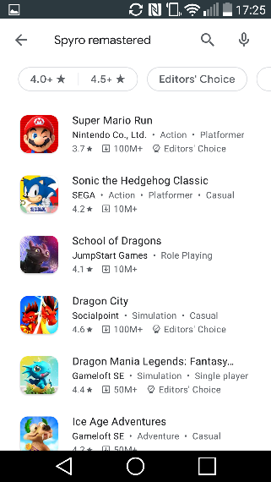When searching the terms “Spyro” and “Spyro Remastered Guide” into the android play store there seems to be no app related to that game overall with most of the returns being games about dragons or based on Skylanders. Since there were no Spyro apps or game guides, I searched up a broader term so that I could get a look into some of the top game guide apps on the store. I decided on comparing two different game guides one for Resident Evil 2 and one for Undertale.

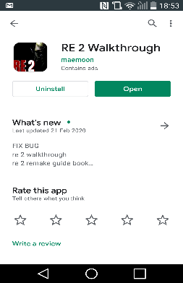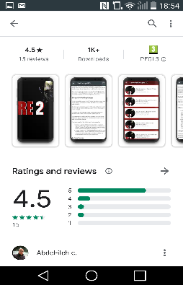

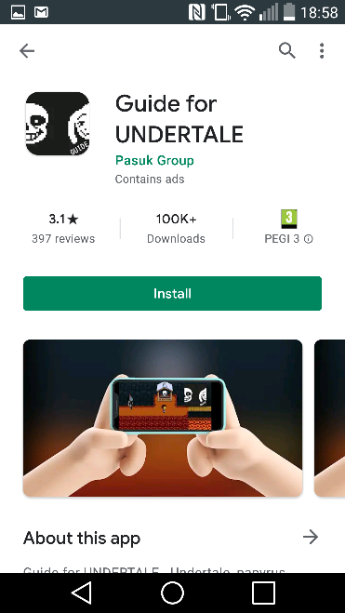

**Good practice and gaps in the market:**

From my research into existing apps, I took a look into both of the apps to see how they were designed and why they were mostly liked by the people who downloaded them.

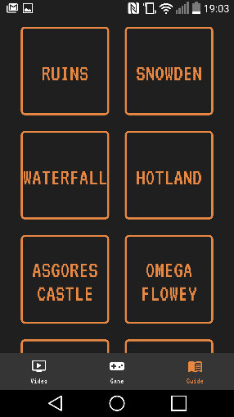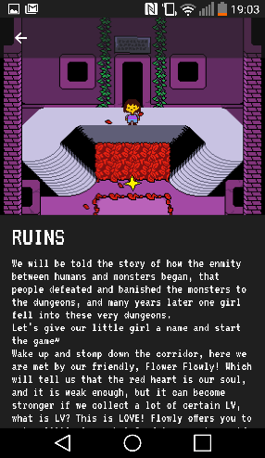

Simple tiles to indicate what level guide the user will be looking at.

Simple and clean UI to navigate

Nice image to go with it and good use of the font for the guide.

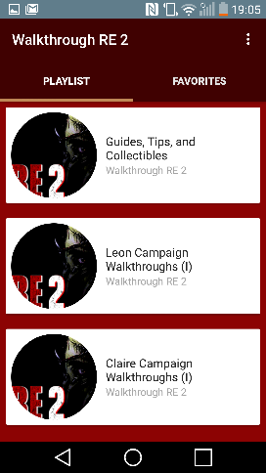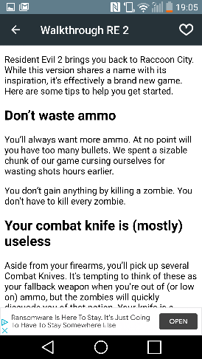First are two screenshots from the Undertale game guide app. I really like the navigation of this app with the clear icons at the bottom that take you to each section of the app. I also like how the app has tiles for each level and when the user taps, it navigates to that levels guide in the app, these designs will be incorporated into my design with some small changes. I also like the use of font in the actual game guide.

The guide is somewhat structured well, but it lacks UI.

The game guide is structured better than the Undertale guide with headings and useful information.

From this app the game guide was structured a bit better with headings and info compared to the Undertale guide. However, it lacks the simple and clean UI the Undertale guide had.

From my initial search of game guides or apps relating to Spyro the remastered trilogy I found that there was not really any apps at all for that game so there is a gap in the market for a walkthrough app like mine.

**Iterate on existing apps and how to improve them**:

In terms of iterating on these apps I can take the UI elements from the Undertale guide and incorporate them into my app. I will iterate the design by putting more structure into the tiles in terms of separating them by homeworld and have each of the levels underneath them with text and an image to go with it in case the user does not know the name of the world. I will also take the better structure of the game guide from the Resident Evil guide and incorporate it into the app, this design will also be iterated upon by adding more images and structure to the guides themselves as well as the inclusion of the video so that users can get an even better look at what to do as well as providing different types of guides, so the user has options.

**Requirements are needed to achieve the finished app:**

Building the app should be quite simple with UI elements and some animations for extra flare. The time-consuming part would be the collection of all of the assets as I would need to record a full 100% playthrough of the game and edit together all of the clips for the levels and upload them all and embed them into the app. During this playthrough I will also be getting screenshots for each character and level so I can add them into the app aswell. My concern with the playthrough is that if I mess up on any recording I will have to playthrough the game again till that point and record again as there is no way to bring back the gems, however I can redo the orbs.



Wireframes

100% Walkthrough

3

2

Home Page

1

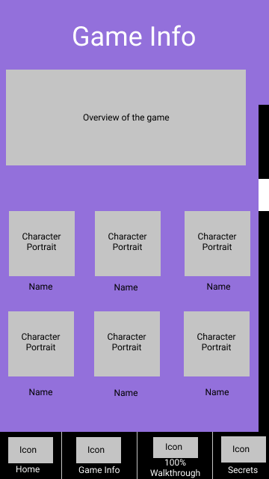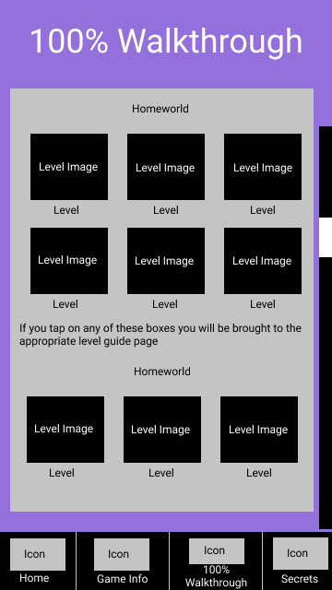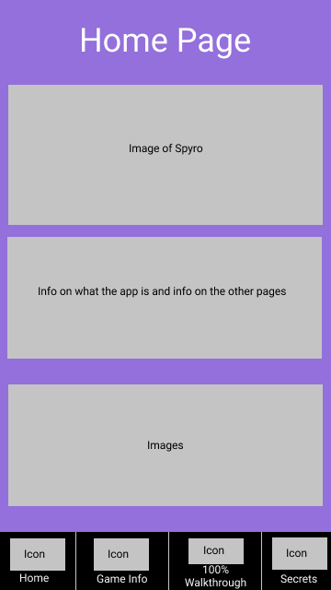

Game Info

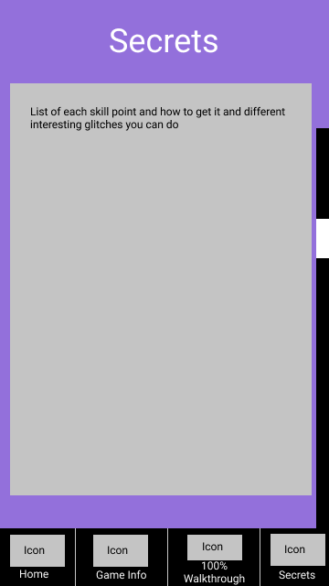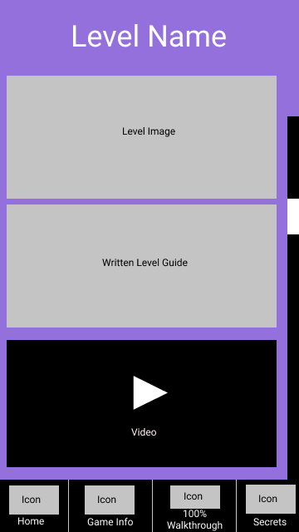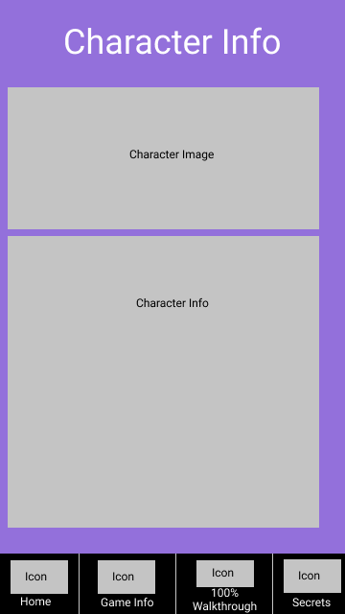

6

Secrets

Level Name

5

4

Character Info

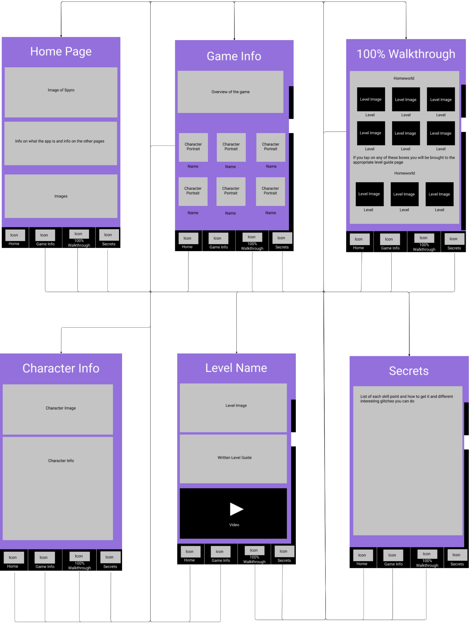

Wireframe Flow Diagram

Composite’s

3

Home Page

2

1

100% Walkthrough

Game Info

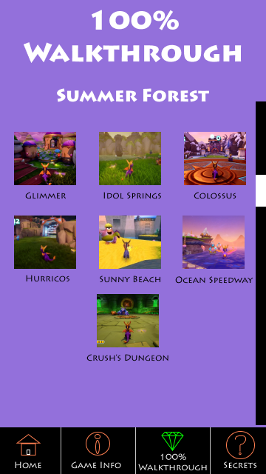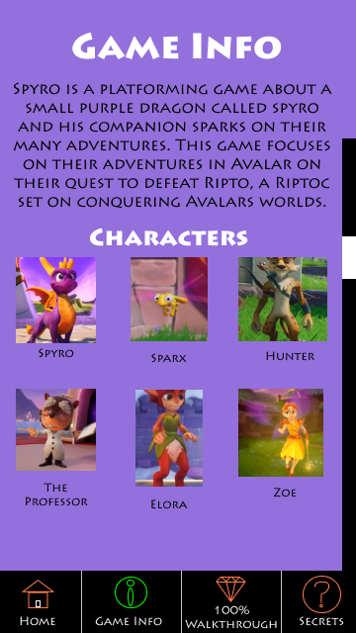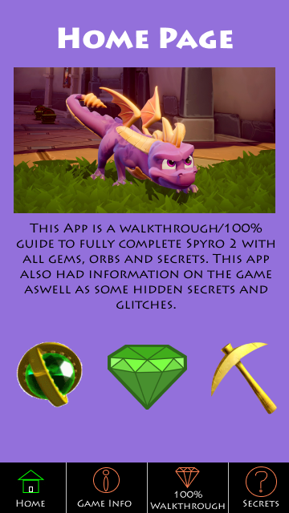

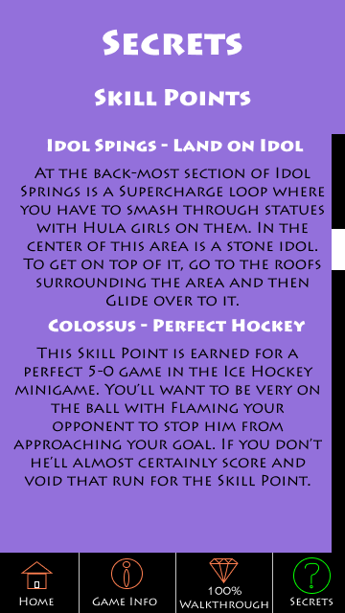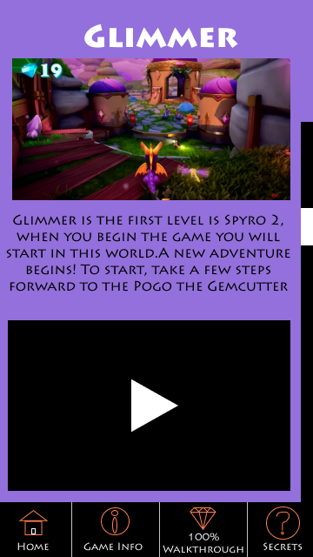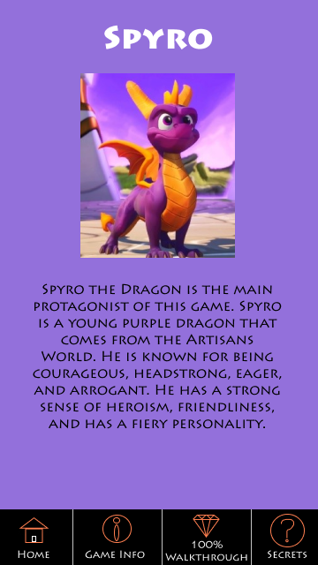

6

Secrets

Level Name

5

Character Info

4